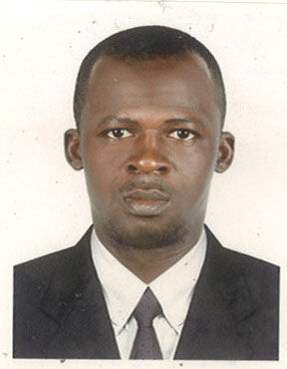**CURRICULUM VITAE**

**FAISAL YAKUBU.**

**Mob: 97156 960 6541**

**Email: bagi50004u@gmail.com**

**Abu Dhabi, U.A.E**

**Objective**

I am a hard-working, motivated enthusiastic individual with a proven track record in my field of work. I always strive to achieve the highest standard possible, at any given task in any situation. I am accustomed to working in a challenging and fast-passed environment, particularly when dealing with multiple projects and priorities at the same time.

**Personal Details**

Name : **FAISAL YAKUBU**.

Nationality : GHANA.

Date of Birth : 10.10.1984

Gender : Male

Marital Status : Single.

**Educational Qualification**

* Basic Certificate.
* Senior High Certificate

**Work Experience:**

* Presently working as an **Office Administrator** with **Motor zone Auto Repair** in Abu Dhabi United Arab Emirates. From 2017 till date.
* 3 Years working Experience as a **warehouse assistant** with **Tema Habour Authority** Ghana from 2009 to 2012.
* 3 Years working Experience as a **warehouse assistant** with **SIGMA GHANA Ltd.** From 2013 to 2016.

**Skills:**

* Spirit of team work
* Adoptability of environmental changes.
* Excellent Communication skills.
* Hard working creative and honest.
* Ability to work and initiate result oriented.
* Excellent interpersonal, verbal and written communication skills.
* Strong commitment to the assigned tasks and result oriented.

**Declaration**

I hereby declare that the above furnished information are true and correct in best of knowledge and belief.