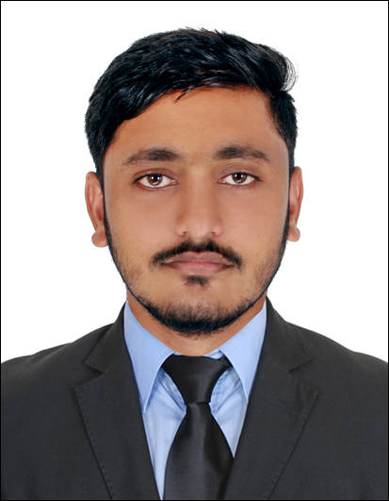
Osama shad
Address –Life Pharmacy Building Flat num901,
Near Al Zahra Hospital
Sharjah UAE

Visa Status – Visit Visa (Till 4 March 2020)
Contact no. +971561839022
Email ID: shadosama50@gmail.com

CAREER OBJECTIVE

To make a professional growth-oriented career in the field with good organization where I can utilize my knowledge and professional experience in line with organizational objectives and to work in a professional atmosphere, which will allow expanding my interpersonal skills.

CARREER SNAPSHOT

One year of experience as a Service Engineer with Madhuban Toyota Pvt Ltd Kurla Mumbai. Service maintained experience with automobile industry, Car Inspection, 4stroke engine, Brake, Suspension, Exeats system, ECM, BCM, Body shop, Paint, MS-Office & DMS, Estimate provide, Man power &work control, Satisfied Customer, Spare part, Team work

ACADEMIC QUALIFICATION

- Diploma in (mechanical engineering) from Rajiv Gandhi Proudyogiki Vishwavidyalaya year 2018 with passed first division

- High school from CBSE in year 2014 with passed First division.

SKILLS

- Strong analytical communications

- DMS

- M-S office

- Knowledge of computer software managing. as well as AutoCAD, Catia,

- Complete Knowledge about Internet.

- Emailing all the details of the entire related employee.

WORK EXPERIENCE

- Service Advisor in Madhuban Toyota Pvt Ltd Kurla Mumbai .19th May 2018 to 10th January 2019
Duties and Responsibilities
- Greeting customers and scheduling service appointments

- Check workshop situation and promise delivery time

- Cataloguing customers concerns and comments

- Writing service orders and descriptions of problems and repairs

- Translating customers repair problems into standard repair terminology

- Explaining repairs to customers

- Test-driving vehicles to confirm service repairs

- Estimating the cost and time needed for repairs

- Handling customer complaints

STRENGTHS

- Total involvement and an undying enthusiasm in anything undertaken.

- A good communication has an effective clear & convincing way.

- Decision making & problem-solving skills.

- Short learning curve pay attention to detail & keen to learn.

- Committed to excellence.

- Flexible, Sincere, Motivated, & Professional.

PERSONAL DETAILS

- Date of birth | - 06/08/1999
- Fathers name | - Mr.Gulshad
- Nationality | - Indian
- Gender | - Male
- Marital status | - Single
- Language | - Hindi, English & Urdu
- Hobbies | - Playing chess, Listening Music & Photography
DECLARETION

I hereby declare that all the information given above is true in every respect to the best of my knowledge. I shall adhere and abide company rules, regulations and policies.

