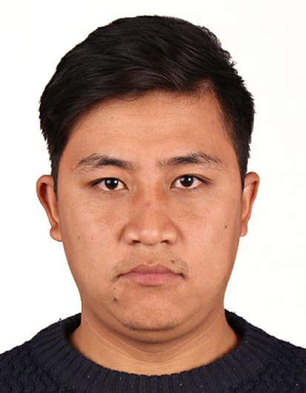

**BIKASH TAMANG**

AL WAHDA, SHARJAH (UAE)

MOBILE: 0524958564

E-mail Address: **satyalshanta555@gmail.com**

**CAREER OBJECTIVE**

To work diligently and apply my critical skills and expertise for a highly challenging career in retail sales or Hotel in a professional organization where opportunities exists for professional growth and career advancement.

* **Professional experience of over 2+ years in Hotel in UAE.**

**CAREER HISTORY**

Designation**: Bell Boy**

Organization**: COSMOPOLITAN HOTEL LLC DUBAI U.A.E**

Duration**: 22-06-2016 TO 17-06-2018 (2 YEARS)**

**Summary of Job Profile:**

* Uploading and loading luggage
* Handling Guest luggage on Arrival and Departure
* Entering and leaving Guest’s Room.
* Escorting and Directing Guest.
* Rooming the Guest
* Arranging Transportation
* Handling Lost and Found items

Designation**: Sales Associate**

Organization**: UFO**

Duration**: July 2018- May 2020**

**Summary of Job Profile:**

* Handled customer complaints and suggestions in a professional manner.
* Focused on achieving daily/weekly/monthly targets through efficient selling skills.
* Handled cash counter ensuring ZERO variance in cash and card transactions.
* Ensured the customer satisfaction on top most priority.
* Advised customers on selecting value for price products and new collections with demonstration whenever required.
* Advised section in charge on fast moving and slow moving inventory for timely placement of LPOS.

**KEY AREAS AND STRENGTHS:**

* Exceptional communication skills, quick learner and able to adapt new technology.
* Highly motivated, perseverance, confident has been successful in previous assignments.
* Effective working alone or as a cooperative team member.
* Passionate, hard worker and well organized professional with power to prioritize and multitask.
* Ability to meet deadlines.
* Flexible to work in non-business hours.

**ACADEMIC QUALIFICATIONS:**

* School leaving Certificate (SLC)
* High School (+2) commerce

**PERSONAL DETAILS:**

**Sex:** Male

**Date of Birth:** 19th April, 1994

**Nationality:** Nepalese

**Languages Known:** English, Hindi & Native

**Visa Status:** Visit Visa

***REFERENCE:***

* Availabe on Request