SAHIBZADA MUHAMMAD
SHAHZAD

Address: Industrial Area #2 Sharjah (UAE)
Contact # +971 50 9 967 967
Email ID: shahzad_toyota@hotmail.com
I have valid UAE DRIVING LICENSE.

- Personal information:

Father name : Sahibzada Muhammad Shahid 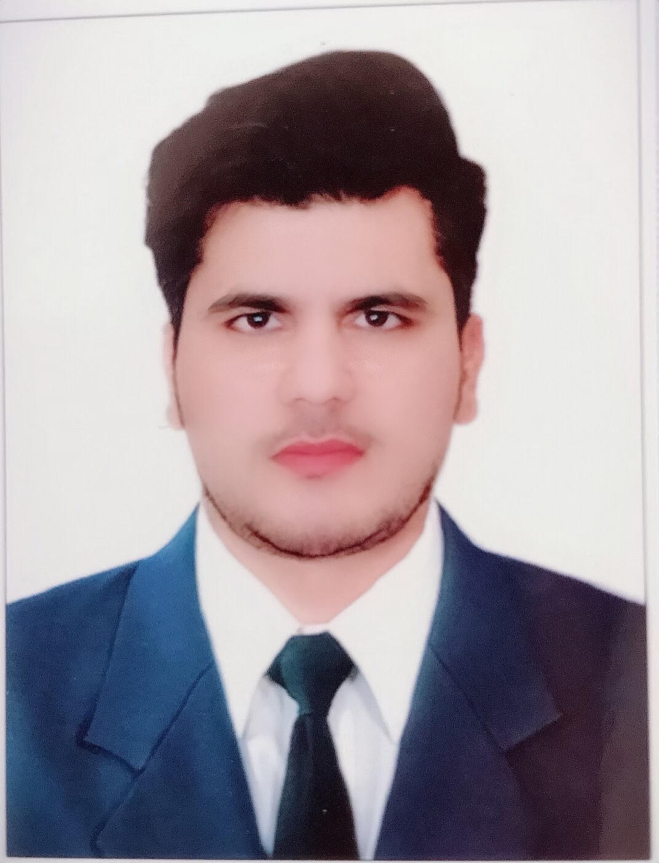
Date of Birth : 02/11/1986
CNIC No. : 17301-8115814-9
Marital status : Married
Nationality : Pakistani
Passport no : KY5148142
_______________________________________________________________

- OBJECTIVE:
- Looking for a position in dynamic organization where I can put my theoretical knowledge to practice and can improve my skills by purposeful and challenging assignments.
___________________________________________________________________________

STRENGHT
- Hardworking Confident and commitment ability to work Under Pressure in any Circumstances. Ability to give Excellent Quality output and copes with Heavy volumes.
- Selling parts, responding to customer inquiries, and assisting them in identifying part numbers, and recommending substitutions for unavailable parts.
- MAIN DUTIES
- Fills customer purchase orders from stock and follows-up on their delivery.

- Prepares quotations for available parts and forwards inquiries for non-available parts to suppliers.

- Recommends substitution for unavailable parts.

- Identifies part numbers as needed by customers and other branches.

- Prepares computer draft for warehouse of received parts.

- Prepares invoices for received and sold parts.

- Rechecks and packages parts to be delivered to customers.

- Updates entries in the system and follows up on purchase orders.
- Submits monthly report listing clients with outstanding balances.

________________________________________________________

- Qualification
Secondary School Certificate from Govt High School Zaryab colony Peshawar Pakistan.
Diploma of Commerce from Khyber College of Commerce and Management Peshawar.
__________________________________________________________________________

COMPUTER SKILLS

My skills give me a competitive edge over others,

- OPRATING SYSTEMS: DOS, Windows 9x/2000/NT/XP (Operation plus Installation)
- APPLICATION SOFTWARES: Ms-Word, Ms-Excel, Ms-Power Point, Ms-Front
Page, Inpage2000, Internet.
- GRAPHICS SOFTWARES: Corel Draw 11, Adobe Photo shop 7, ACDSee 6.0.
- HARDWARE: Well knowledge about hard Disk Partition, Formation and
All Type of Peripheral Installation.

- Languages
  - Speak, Read & Write English
  - Speak, Read & Write Urdu
  - Speak, Read & Write Pashto
  - Speak Arabic
  - Speak Pharsi
_________________________________________________
- Experience
- 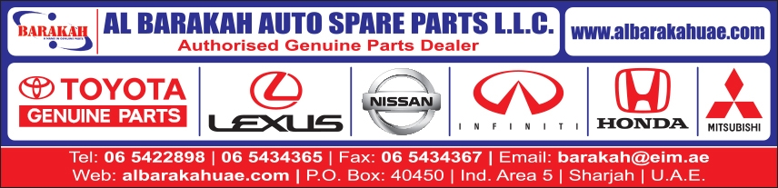

Organization : Al Barakah Auto Spare Parts L.L.C Sharjah UAE.
Designation : Sale Executive Toyota genuine parts
Period : March 2005 to April 2008.

- Responsibilities :
- Build Customer Relation Ship.
- Good Team Work.
- Where house Management.
---------------------------------------------------------------------------------------------------
Organization : 
Toyota Frontier Motor University
Designation : Sale Executive Parts.
Period : February 2008to January 2009.

- Responsibilities :
- Daily Cash & Fleet Sale.
- Prepare Daily Order.
- Update day to day Transaction.
-------------------------------------------------------------------------------------------------
Organization : Zahid & Ismail Auto Spare Parts L.L.C Sharjah UAE.
Designation : Sale Executive Toyota & Nissan. Accounts
Period : March 2009 to April 2012.

- Responsibilities :
- Build Customer Relation Ship.
- Good Team Work.
- Assist Inventory Controller.
-------------------------------------------------------------------------------------------------
Organization : 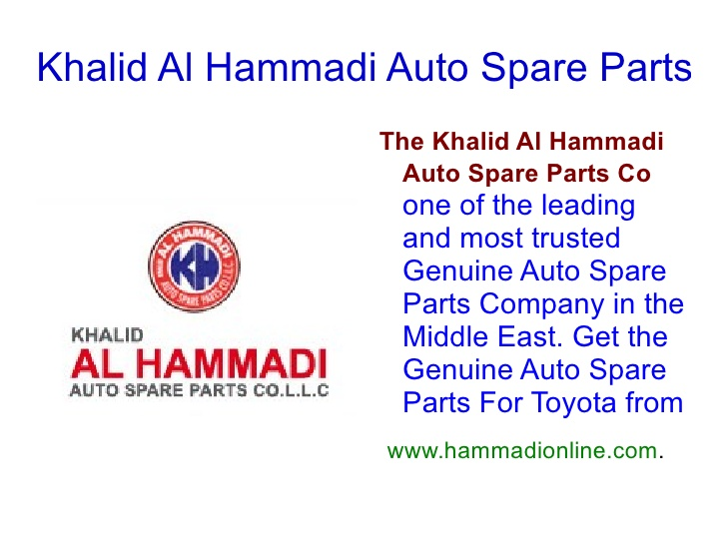
Khalid Al Hammadi Auto Spare Parts Co. L.L.C
Sharjah UAE.
Designation : Brch Manager & Parts Manager Toyota Genuine Parts.
Period : July 2012 – Present…

Responsibilities : Hired and evaluated work of all staff members working in parts department.

Monitored inventory for all parts level and adjusted it to minimize any kind of obsolesce.
- Developed and implemented policies for ordering special parts.
- Analyzed all inventory and sales of parts and ensured compliance to all profit goals.
- Participated in manager and department and analyzed programs and recommended changes.
- Maintained department operations and changed layout on regular basis to ensure effectiveness.
- Administered employee payrolls and ensured timely completion of all paperwork.
- Monitored customer complaints and ensured resolution within company guidelines.

LICENSE :
UAE Valid Driving License.
04/05/2017 TO 03/05/2027

References:
To be provided on request.

