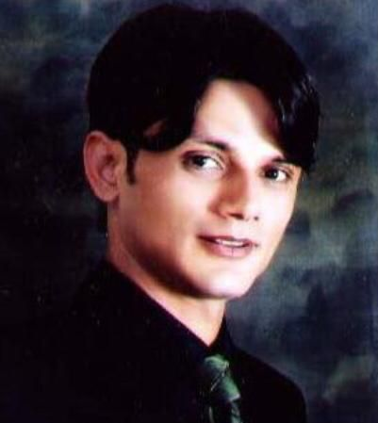

SHARIQ AKHTAR

Industrial Area 2 K1 Building, Sharjah, UAE

Mobile No.: +971-55-8960310

E-mail: [shariqalam2002@gmail.com](mailto:pcpjavier27@gmail.com) ;

*OBJECTIVE*

*To work with a reputable company that could utilize my potential and offer continuous career development.*

*EDUCATION*

*1998*

*HSC*

*Little Paradise*

*Karachi, Pakistan*

*SUMMARY OF QUALIFICATIONS AND SKILLS*

1. *Known for the ability to learn, accept and apply changes, methodologies, concepts, and ideas.*
2. *Computer Literate (MS office)*
3. *Can communicate and write in English and Urdu*
4. *Customer Service / Sales Management / Accounting*
5. *Able to work under pressure to competing demands and stakeholders; strong customer focus*

*EXPERIENCE*

*2017- Till Present*

*Sales Executive & Marketing*

***BSG AUTO SPARE PARTS TRD L.L.C***

*Deira Dubai U.A.E.*

* Sales executive of (BSG) Auto spare parts and automotive Batteries & Tires.
* Handling Local Market Sharjah, Ajman, Al Ain, Abbu Dhabi, Ras Al Khaimah.
* DEALS IN. Ford, Mercedes-Benz, Volkswagen, Opel, BMW, Peugeot, Citroen, Hyundai, Kia, Audi, Seat, Skoda, Land Rover, Mini and Chevrolet.
* Handling Export Pakistan Market.
* Supervise sales team and follow up
* Set monthly Targets as per territories
* Receiving sales reports
* Manage stock inventory
* Meeting more clients and suppliers for more business
* Follow Up with Clients by Email Phone and WhatsApp
* Collect Orders and Provide Good Serves to Clients
* Purchasing original and aftermarket parts from local companies
* Getting New Customers and Assisting the existing customers
* Prepares Sales Invoices (for retail)
* Handling Import purchase

*2014-2016*

*Senior sales executive*

***New East General Trading***

*Deira Dubai U.A.E.*

* *Senior Sales executive of (****HITACHI****) battery’s Tires and automobile spare parts for all cars.*
* *Hitachi Automotive Battery Sales Export and UAE Market.*
* *Manage day to day clients*
* *Handling Local UAE and Export Customers*
* *Relationship building and client maintenance*
* *Handling client communication and resolution*
* *Meeting more clients and suppliers for more business*
* *Taking a proactive role and having the ability to propose creative ideas*
* *Coordinating with the upper management and with sales team to reach the target on monthly basis*
* *Helping the sales team on how to reach monthly target*

*2011 – 2013*

*Sales Professional*

***T.T. AUTO MOTIVE L.L.C.***

*Al Maktoum Hospital Street, Near Riga Hotel. Dubai*

* *Sell and purchase*
* *Getting New Customers and Assisting the existing customers*
* *Provides customers' satisfaction*
* *Handling Tp And Taiho japan for local market in UAE and export market.*
* *Collecting Payments*
* *Provide better deals to each customer*
* *Payment Plans*
* *Promoting the brand*
* *Building Rapport to the Customers*

*PERSONAL INFORMATION*

*Age : 41*

*Citizenship : Pakistani*

*Civil Status : Married*

*Visa Status : Employment Visa*

*Driving License : Yes*

*I certify that the above-mentioned information is true and correct to the best of my knowledge and belief.*

*Shariq Akhtar Alam*